# Intradiem Adherence and Staffing

[Your Responsibilities](#_Toc160013910)

[ Early Break, Lunch Break, Event and Shift End Notifications](#_Toc160013911)

[PTO/FHOL/UTO/OT Question Prompts](#_Toc160013912)

[End of Shift Early Out Opportunity](#_Toc160013913)

[Frequently Asked Questions](#_Toc160013914)

[Related Documents](#_Toc160013915)

**Description:** Intradiem is a resource designed for CCR’s which integrates the automation of adherence notifications and offers of time off or overtime when conditions require it. This job aid highlights responsibilities and expectations as Adherence and Staffing rules are implemented through the Intradiem Solution.

|  |
| --- |
| Your Responsibilities |

1. To ensure you receive alerts, messages and schedule offers, and remain logged into the Intradiem Desktop.
2. Take calls as usual and await staffing offers, messages or sessions:
   * These will likely arrive as prompts on your Desktop (above open applications).
   * Check your messages after you’ve been away from your computer.
   * When you receive a Yes/No question, answer the question either way.
   * After you respond, take necessary actions based on the offer and processes.
3. Prior to attending a scheduled event/activity (**Examples:** Lunch, break, or training):
   * Complete the customer interaction first.
   * Refer to your schedule in NICE to ensure adherence.
   * Change phone state (as appropriate) and attend event/activity.
   * When complete, return to your next scheduled activity.

[Top of the Document](#_top)

|  |
| --- |
| Early Break, Lunch Break, Event and Shift End Notifications |

Intradiem can help you get off the phone in time for lunches, breaks, scheduled events or before shifts end. Below are examples of what you can expect.

1. Figure 1 provides an example of lunch and break notifications.   
     
   Notice that Intradiem:
   * Knows the break/lunch is coming up
   * Knows if you are/are not on a call
   * Updates schedules automatically

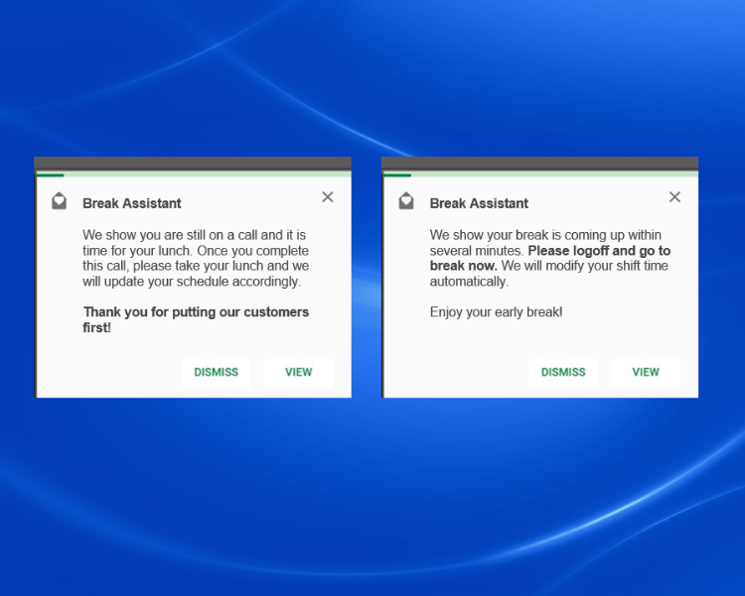

**Figure 1**

**Note:** If leaving early for break or lunch, be aware of when you leave to ensure you are back on time and within the required interval.

1. Figure 2 provides an example of a question you may be asked instead of receiving a notification. This option gives you the option to go early.  
     
   **In this example:**
   * Answer Yes or No
   *  If you answer Yes, change Not Ready Status for break or Log Out for lunch.

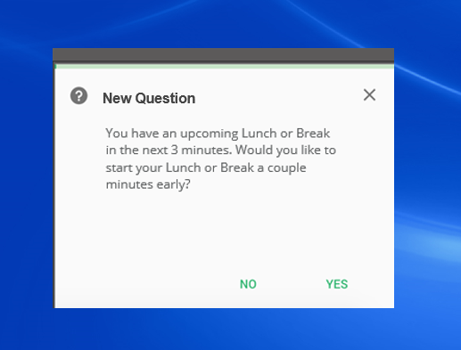

**Figure 2**

**Note:** Answer Yes or No in response to any question prompts.

[Top of the Document](#_top)

|  |
| --- |
| PTO/FHOL/UTO/OT Question Prompts |

You may receive offers of PTO, FHOL, UTO or OT. These offers can be passed along via an Intradiem prompt.

1. Figure 3 provides examples of questions wherein you will have an opportunity to accept an offer via a Yes or No response:  
     
   **In this example:**

* Answer Yes or No
* If answer Yes, you will receive a confirmation message with instructions

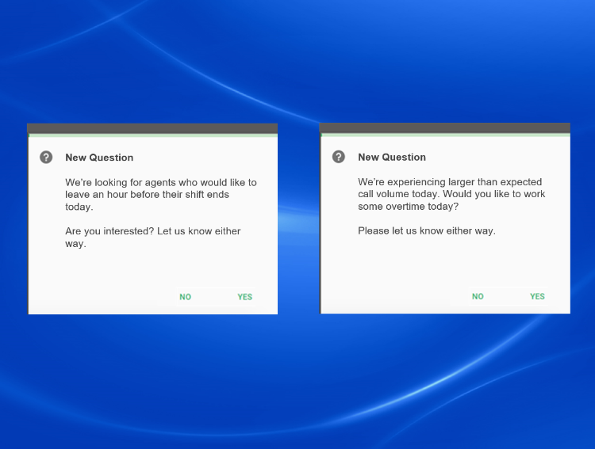

**Figure 3**

**Note:** Answering Yes is NOT a guarantee of acceptance, so please await confirmation.

[Top of the Document](#_top)

|  |
| --- |
| End of Shift Early Out Opportunity |

As our Care PBM business conditions allow, the Resource Planning team may offer you an opportunity to leave early via the Intradiem tool. (Within a period of less than 5 minutes prior to your current day scheduled shift end time.)

1. Figure 4 below provides an example of a screen prompt you may expect to see when presented with an End of Shift Early Out opportunity:

Once the offer is accepted by selecting **Yes,** you will have the opportunity to complete your work and log off within your scheduled shift end time for the current day.

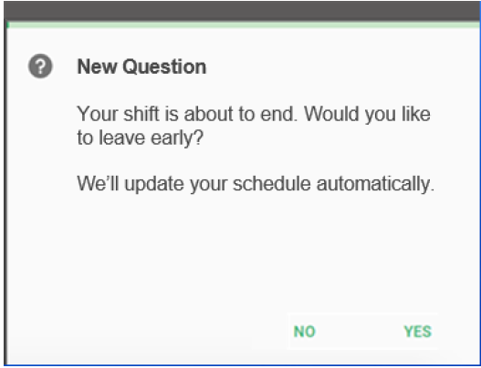

**Figure 4**

Your schedule will then be updated in NICE WFM and Workbrain to reflect the actual time you logged off.

**Notes:**

* The end of shift early out offer is a paid offer and will be paid per your regular pay rate and based on your current day scheduled shift hours.
* If for any reason you are unable to complete your work ahead of the early out time, you will continue to be paid until you have successfully logged off for the day.
* You are paid for all time associated with working time.
* The maximum duration of this early out and regular pay is 5 minutes.

[Top of the Document](#_top)

|  |
| --- |
| Frequently Asked Questions |

Refer to as needed:

|  |  |
| --- | --- |
| **Question** | **Answer** |
| What should I do if I miss a PTO, FHOL, UTO or OT offer? | Unless informed otherwise, it will be necessary to wait for another offer. |
| Are there a limited number of PTO/FHOL/UTO/OT offers sent to agents? | Yes. Generally, a limited number are sent out. Once the required number of offers are accepted, they are no longer sent out. |
| If I accept a PTO/FHOL/UTO/OT offer, how will I be notified that it was approved? | An Intradiem prompt will be sent as a confirmation alert with noted instructions. |

[Top of the Document](#_top)

|  |
| --- |
| Related Documents |

[Customer Care Abbreviations, Definitions and Terms (017428)](https://thesource.cvshealth.com/nuxeo/thesource/" \l "!/view?docid=c1f1028b-e42c-4b4f-a4cf-cc0b42c91606" \t "_blank)

[Top of the Document](#_top)

Not to Be Reproduced or Disclosed to Others Without Prior Written Approval

**ELECTRONIC DATA = OFFICIAL VERSION / PAPER COPY = INFORMATIONAL ONLY**